RegisterBlast
Information Technology Solutions

Methodist College
Testing Services
7600 N Academic Drive
Peoria, IL 61615
Phone 309.672.5530
Email: testing@methodistcol.edu

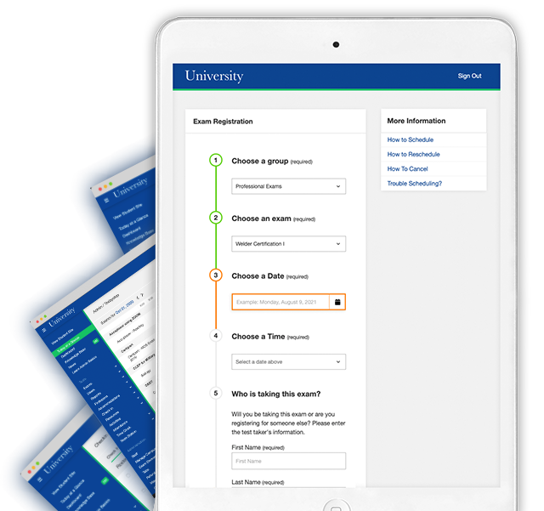
How to Schedule
Simply go under your D2L, click on the MC Resources drop down menu >RegisterBlast and follow the next steps:

- Select “Academic Exams”
- Select and verify that all your testing information is correct
(Is it an ADA or Make up Exam/ select correct Course number).
- Choose the exam you wish to schedule
- Select an available date/time
- Fill out required fields
- Read the Exam Guideline Acknowledgements in the scroll box
- Check the boxes under the scroll box to acknowledge the guidelines
- Once you are ready, click “Add to Cart”
- If you are adding more exams, click the “Add another exam” and repeat previous steps
- Click “Ready to check out” (Payment is not required for ADA or Make-up Academic Exams).
If you have any questions, please stop by the Testing Center during open hours and we will be happy to assist.

You must register for your exam at the latest 2 days prior to testing time.

If you have ADA approved testing accommodations, please submit your exam schedule in full ASAP.

More information links are found in your RegisterBlast registration page.

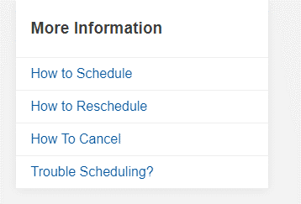
Testing Center Hours

Mon-Fri: 7:30am-4pm

Mon & Wed: 4pm-6pm by appointment only

Sat & Sun: Proctor available during scheduled exams only
RegisterBlast is a tool designed to help make Exam Scheduling an easier process for Students.

You no longer need to email or call Testing Services to schedule your exams.

You can register for your ADA accommodated exams or approved make-up exams, without having to wait for a response from the Testing Center during business hours.
You can see what is open and schedule right away!
New Testing Center Scheduling System

